|  |
| --- |
|  |
| Requirements Document |
| Project Name: Impact/Dependency Traceability Application |
|  |
| **Evgenia Luchenok** |
| **19.03.2014** |

|  |
| --- |
|  |

Revision History:

|  |  |  |  |
| --- | --- | --- | --- |
| **Version** | **Date** | **Author** | **Change Description** |
| 1.0 | 03/19/2014 | Evgenia Luchenok | Initial Draft Creation |
| 1.1 | 4/24/2014 | Evgenia Luchenok | Updated mock-up for Add New Task screen. Added requirements for Add New Task. |
| 1.2 | 5/6/2014 | Evgenia Luchenok | Updated mockups for Add New Task (Input&Output part)  Added requirements for condition types when Adding a New Task  Added mockups for View and Update Task pages. |
| 1.3 | 5/7/2014 | Evgenia Luchenok | Added mock-ups for pop-up to add/update conditions for input/output |

Contents

1. Project Overview 3

1.1. Background 3

1.2. Project Purpose 3

1.3. Product Description 3

2. Glossary 3

3. Business Requirements 3

4. Mock Ups 6

4.1 Home Page 6

4.2 Add New Task Form 7

# Project Overview

## Background

Currently there is no transparency in how processes in 1Cloud are held and managed. It takes significant time and effort to determine the dependencies between different processes in the system, its start/end points and what impact they have on each other. That slows down the work of Business Analysts, Developers and Testers during the estimation as well as requirements gathering, developing and testing the features.

## Project Purpose

The main purpose of this project is to develop a tool that would provide means to store and track information about 1Cloud processes/tasks and their interdependencies between each other. The goal is to make this information available and easy to find for all 1Cloud team members.

## Product Description

A new web-based application is designed to add and describe each new task in 1Cloud that is being developed by CSI team. It empowers all members of Evolution1 project with capabilities to view existing tasks and understand how they work, discover how they affects the others and what dependencies these tasks have. To keep stakeholders up-to-date it also notifies users of the newly added tasks and latest changes with ability to view history of changes.

# Glossary

**Task** (Given Task) – piece of work that must be performed in order to produce a desired value, which is useful, specific, visible and measurable for 1Cloud users.

**Input** – represents information and preconditions necessary for a Given Task to begin.

**Output** – necessary result of work described in a Given Task.

**Impact** – Task that self-sufficient and can be performed without the Output of a Given Task but their execution is affected by it.

**Dependency** – Task that using a Given Task Output as an input and cannot be started without it.

# Business Requirements

| Business Need | Description | Business Rules |
| --- | --- | --- |
| Capability to Access the Application | Evolution1 project member should have access to the application. | The user should be able to authenticate himself in the application.  To successfully authenticate the user must specify email address and password.  Email address should be the same as used by the user within the company (CoherentSolutions domain).  Password should be the same as used to login to the local PC.  A new user should be able to register in the application.  Only members of Evolution1 project can be registered in the application.  Any registered user should be able to update his user profile information. |
| Capability to Create New Tasks | Application should provide ability to add new tasks. | The user should be able to create new tasks.  Only Business Analysts or Project Managers can create new tasks.  The system should provide capability to identify new task as general or partner specific availability.  System must track who added the task and when. |
| Capability to View Tasks | Application should give the user ability to find any existing tasks and view it. | The user should be able to initiate a search for a task.  The system should return all tasks that contain the entered text in the search input.  The user should be able to view the found task.  The user should be able to update existing tasks.  Only BA and Project Manager should be able to update all properties of the task. The users with other roles than BA or PM should be allowed to update only information about how the output of a Given Task affects other tasks.  The system should notify user how many new tasks have been added since the previous login.  The user should be able to view all tasks that exist in the application.  Newly added tasks should be highlighted. |
| Capability to View Recently Modified Tasks | Application should track all the changes made for the existing tasks. | The system should historically track all tasks updates.  System must track changes and capture User, Date/Time and what has been changed (old value and new value).  The system should display change history of the task being viewed.  The system should notify user how many tasks have been updated since the previous login. |

# Mock Ups

## Home Page

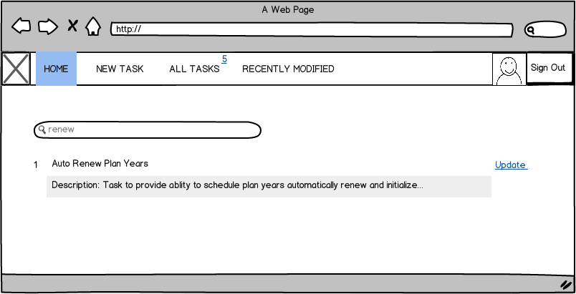

## Add New Task Form

Empty:

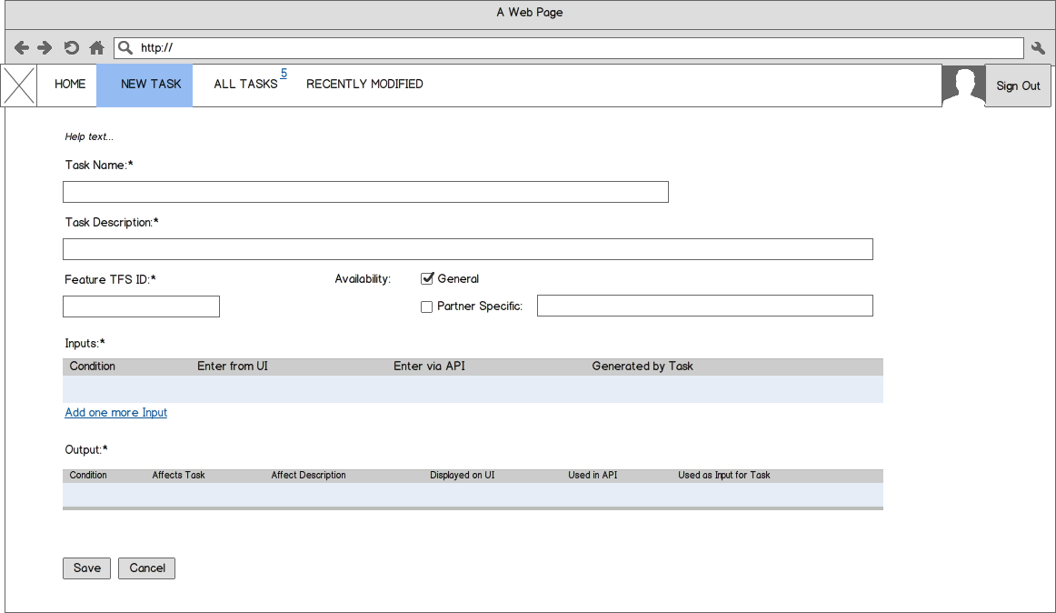

**<Elements Description >**

|  |  |  |  |
| --- | --- | --- | --- |
| Name | Type | Required | Description |
| Task Name | Text box | Yes | Editable |
| Task Description | Text box | Yes | Editable |
| Feature TFS Id | Text box | Yes | Editable, Numeric only |
| Availability | Radio Buttons | Yes | Options: General (default), Partner Specific.  If Partner Specific selected, the system should allow user to specify partner(s). The system performs search by TPA alias or partner’s name (contain the entered text). |
| **Input –** The user is able to specify multiple inputs that consist of multiple conditions. | | | |
| Condition | Text | Yes | The system performs search for existing conditions that contain the entered text in name.  The system allows adding a new condition via additional pop-up.  In pop-up the system allows to specify condition attributes. If Condition type=Setting, then display Condition name as concatenation of Name, Level, Value fields. |
| Enter from UI | Text | No | If existing condition is specified, and it has UI defined, then the system pre-populates the field with this UI.  Displayed in read-only mode when New Task is being added. |
| Enter via API | Text | No | If existing condition is specified, and it has API defined, then the system pre-populates the field with this API.  Displayed in read-only mode when New Task is being added. |
| Generated by Task | Text | No | Non-editable. The system pre-populated the field with the Task Name if there is an existing task that has the defined condition as output.  Task Name is formatted as a link, on click opens the Task in a new window in View mode. |
| **Output -** The user is able to specify multiple outputs that consist of multiple conditions. | | | |
| Condition | Text | Yes | The system performs search for existing conditions that contain the entered text in name.  The system allows adding a new condition. In pop-up the system allows to specify condition attributes. |
| Affects Task | Text box | No | If the output condition already has affected tasks, the system pre-populates the field with Task Name.  Displayed in read-only mode when New Task is being added. |
| Affect Description | Text box | Yes, if Affects Task is specified | If the output condition already has affected tasks, the system pre-populates the field with the stored description of how the task is being affected.  Displayed in read-only mode when New Task is being added. |
| Displayed on UI | Text box | No | If existing condition is specified, and it has UI defined, then the system pre-populates the field with this UI.  Displayed in read-only mode when New Task is being added. |
| Used in API | Text box | No | If existing condition is specified, and it has API defined, then the system pre-populates the field with this API.  Displayed in read-only mode when New Task is being added. |
| Used as Input for Task | Text box | No | Non-editable. The system automatically pre-populates the field with the Task Name where the specified condition is used as Input.  Task Name is formatted as a link, on click opens the Task in a new window in View mode. |

Example:

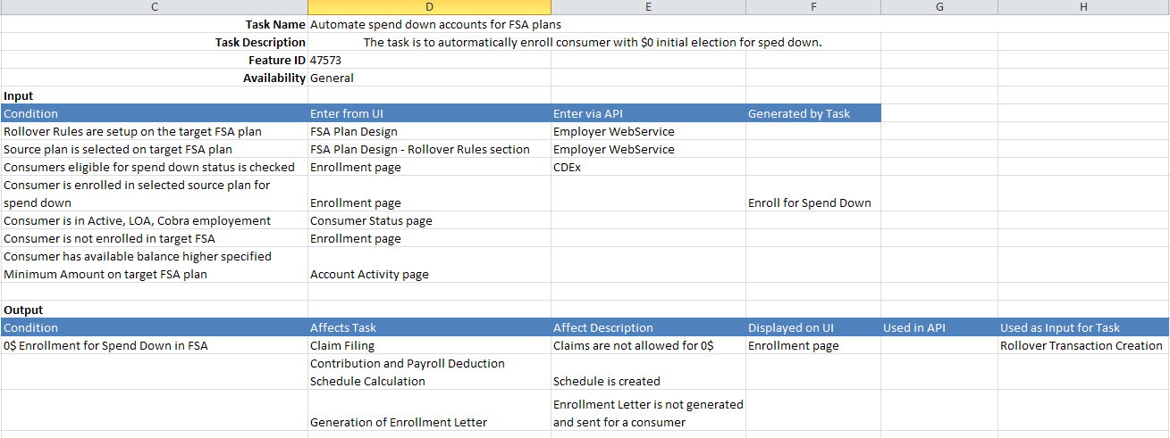

### 4.2.1. Condition Types for Input

|  |  |  |  |  |
| --- | --- | --- | --- | --- |
| # | Condition Type | Example | Attributes | Required |
| 1 | **Setting** | Any level setting is on/off | Name | Yes |
| Level (DB, TPA setup, admin, employer, consumer, plan, enrollment) | Yes |
| Value | Yes |
| Enter from UI | At least one field should be specified. |
| Enter via API |
| Note | No |
| 2 | **Event** (is an action or occurrence detected by the program that may be handled by the program) | Claim is updated.  Consumer is added.  Consumer is moved to another employer.  HSA limit is setup.  Distribution is added online.  Fee is enabled for the employer.  Consumer logs in to the portal.  Consumer is issued a debit card. | Description | Yes |
| Enter from UI | At least one field should be specified. |
| Enter via API |
| Note | No |
| 3 | **File/Data** | XML snapshot is generated.  File is received. | Description | Yes |
| Enter from UI | At least one field should be specified. |
| Enter via API |
| Note | No |
| 4 | **State** (commonly refers to either the present condition of a system or entity) | Consumer is in Status=Active  Uploaded up to 20 documents.  Claim amount > PYB  Consumer HAS account Status = Open  Admin has permission A = R/W | Description | Yes |
| Enter from UI | At least one field should be specified. |
| Enter via API |
| Note | No |
| 5 | **Request** | Request entered to WebService, CRS (to return the data) | Description | Yes |
| Enter from UI | At least one field should be specified. |
| Enter via API |
| Note | No |

### <Add Input Mockup>

|  |  |
| --- | --- |
| *Type=Setting* | *Type=Event* |
|  |  |

Control that allows searching for existing UI/API when entering text

### 4.2.1. Condition Types for Output

| # | Condition Type | Example | Attributes | Required |
| --- | --- | --- | --- | --- |
| 1 | **Setting** | Any level setting is on/off | Name | Yes |
| Level (DB, TPA setup, admin, employer, consumer, plan year, plan, enrollment) | Yes |
| Value | Yes |
| Affects Task | No |
| Affect Description | No |
| Displayed on UI | At least one field should be specified. |
| Used in API |
| Note | No |
| 2 | **Event** | Claim is updated.  Consumer is added.  Consumer is moved to another employer.  HSA limit is setup.  Distribution is added online.  Fee is enabled for the employer.  Consumer logs in to the portal.  Consumer is issued a debit card. | Description | Yes |
| Affects Task | No |
| Affect Description | No |
| Displayed on UI | At least one field should be specified. |
| Used in API |
| Note | No |
| 3 | **File/Data** | XML snapshot is generated.  File is received. | Description | Yes |
| Affects Task | No |
| Affect Description | No |
| Displayed on UI | At least one field should be specified. |
| Used in API |
| Note | No |
| 4 | **State** | Consumer is in Status=Active  Uploaded up to 20 documents.  Claim amount > PYB  Consumer HAS account Status = Open  Admin has permission A = R/W | Description | Yes |
| Affects Task | No |
| Affect Description | No |
| Displayed on UI | At least one field should be specified. |
| Used in API |
| Note | No |
| 5 | **Request** | Request entered to WebService, CRS (to return the data) | Description | Yes |
| Affects Task | No |
| Affect Description | No |
| Displayed on UI | At least one field should be specified. |
| Used in API |
| Note | No |

### <Add Output Mockup>

|  |  |
| --- | --- |
| *Type=Setting* | *Type=Event* |
| Control that allows searching for existing UI/API when entering text |  |

## View Task

On click the system allows to update all fields for a task (available only for BAs)

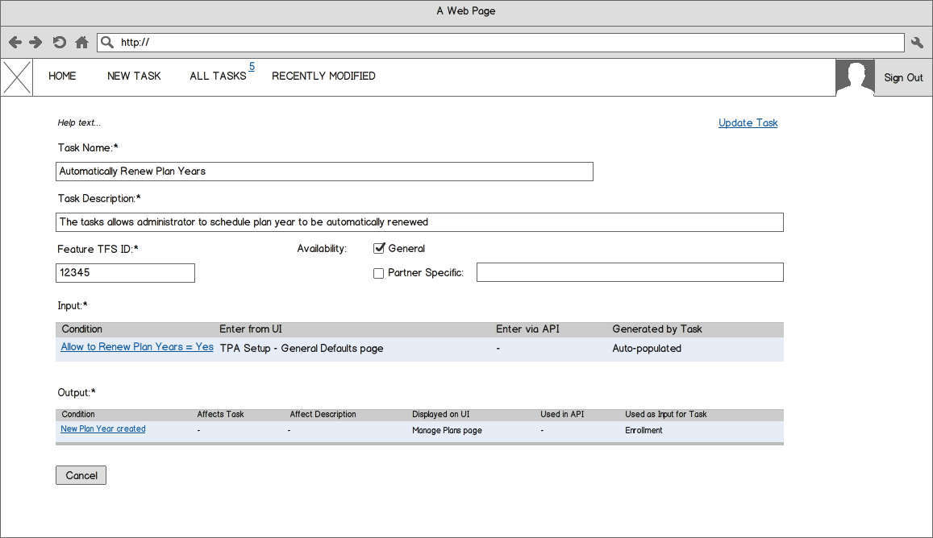

A link opens condition details in pop-up (read-only mode)

## Update Task

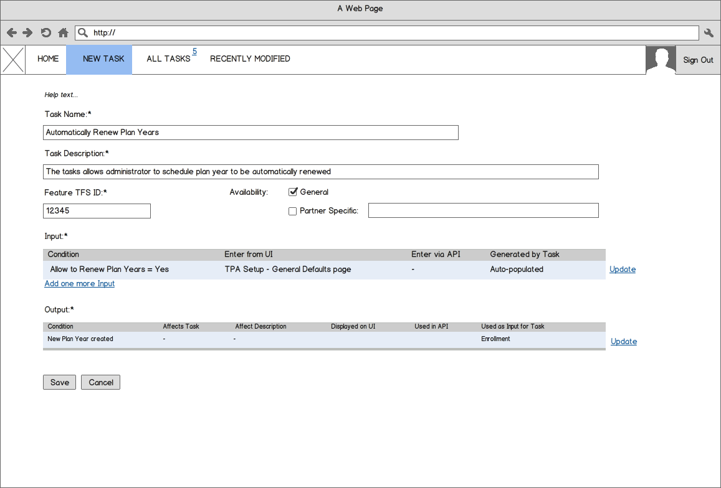

A link opens condition details in pop-up (update mode)